WEB ROUTING

INSTALL CONFIGURATION MANUAL

SLIPPERY ROCK UNIVERSITY

Alexander Dickson - acd1015@sru.edu

Thomas Haley - tjh1019@sru.edu

Beth Orgovan - bro0700@sru.edu

Sinchana Kori - [ssk1002@sru.edu](mailto:ssk1002@sru.edu)

Dakota Myers - [drm1022@sru.edu](mailto:drm1022@sru.edu)

Contents

1 . Application Requirements 1

2. Getting The Application VIA GITHUB / ECLIPSE 1

2.1 Downloading Application via GitHub 1

2.1.1 Locating The GitHub Repository 1

2.1.2 DOWNLOADING THE PROJECT 1

2.1.3 Accessing the Project in Eclipse 1

2.2 Cloning Application Into ECLIPSE IDE 1

2.2.1 Cloning the Application By URI 1

3.Configuring the MYSQL DATABASE 1

3.1 INSTALLING MYSQL 1

3.2 Starting MySQL 1

3.2.1 SERVER STATUS NOT RUNNING 1

4. Setting Up Application Properties 1

5. Starting the Webrouting Application 1

5.1 Running the Project 1

6. Accessing the Application 1

6.1 Where to Access the Application 1

7. Figures 1

# 1 . Application Requirements

**Required Computational Aspects necessary to run this project.**

1. **Java JDK:** JDK 17- Available from[**https://www.oracle.com/java/technologies/downloads/**](https://www.oracle.com/java/technologies/downloads/)
2. **MySQL:** MySQL Server & Workbench **8.0.30** – Available from:<https://dev.mysql.com/downloads/mysql/>
   1. Reference Section 3 for more information
3. **Java IDE:**
   1. **Recommended IDE**: Eclipse IDE for Java Developers -[**https://www.eclipse.org/downloads/packages/**](https://www.eclipse.org/downloads/packages/)
      1. **Version 2022-06**

**4. Updated Internet Browser**

# 2. Getting The Application VIA GITHUB / ECLIPSE

To set up the application it must be downloaded into your system. This section will highlight how to accomplish this.

## 2.1 Downloading Application via GitHub

This sub-section will walk you through how to download a zip folder from GitHub containing all relevant material to the application. Then opening the folder into the Eclipse IDE(See Section 2.1.3).

### 2.1.1 Locating The GitHub Repository

Finding the GitHub Repository where the application is located can be done by following the link below:

**Link:** [**https://github.com/samthangiah/Spring-2023-Web-Routing-Auctioning**](https://github.com/samthangiah/Spring-2023-Web-Routing-Auctioning)

### 2.1.2 DOWNLOADING THE PROJECT with zip file

Once reaching the GitHub repository you will want to be on the ***Code*** tab seen at the top of the page (Figure 1). **Select the code tab and click Download ZIP:**

Figure 1 – Download Zip in Code Tab

### 2.1.3 Accessing the Project in Eclipse

**STOP!**

Before continuing with this section make sure you followed section 2.1.2 and that the project ZIP File is downloaded.

Upon successfully completing section 2.1.2 you will now have a zip file where you designated it to download, access it and extract the zip file downloaded in section 2.1.2. Once extracted there will be a folder titled: ***Spring-2023-Web-Routing-Auctioning-master.***

Now you will open the Eclipse IDE. Eclipse will prompt you for a workspace, navigate to where you extracted the ***Spring-2023-Web-Routing-Auctioning-master*** and select it as your folder as the workspace and select ***Launch*** (Figure 2).

Figure 2 – Launch Eclipse with File as Workspace

Eclipse will launch and you will see the Web routing Application on the side in the Package Explorer (Figure 3). You will need to update the project’s dependencies before continuing (See Section 2.1.3.1 Below).



Figure 3 – Webrouting Application

#### 2.1.3.1 Updating Projects Dependencies

From section 2.1.3 you will right-click onto the ***webrouting*** folder and select ***Maven***, now you will select ***Update Project*** and press ***OK*** (Figure 4).

Figure 4 – Updating Maven Project

Once this has completed you may now move onto Section 3.

## 2.2 Cloning Application Into ECLIPSE IDE

This section will walk you through the steps of cloning the Application from the GitHub repository directly into the Eclipse IDE. This section will outline how to achieve this with the Eclipse IDE and may not work for some Java IDE’s.

### 2.2.1 Cloning the Application By URI

Start the *Eclipse IDE* and launch any workspace. In the top left corner of the *Eclipse IDE* Select ***File***, next you will select ***Import*** (See Figure 5).

***Note-*** See the Requirement Section on Which Java IDE to download (Section 1).

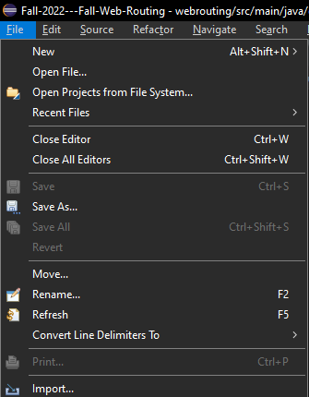

Figure 5 – Import Button

After selecting ***Import*** the ***Import*** window will be open on your screen. You will select Projects from the ***Git*** Folder

This will expand and you will see ***Projects from Git*** and ***Projects from Git (with smart import)***. Select ***Projects from Git (with smart import)*** and select ***Next*** at the bottom of the ***Import Menu*** (See Figure 6).

Figure 6 – Import Menu

After selecting ***Next,*** the ***Import Projects from Git*** window will open, select ***Clone URI*** then click ***Next*** (Figure 7).

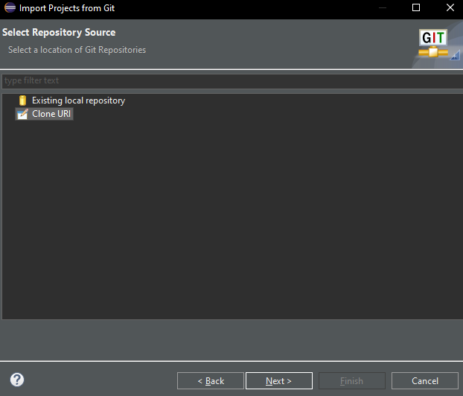

Figure 7 – Clone URI

This will prompt the Source Git Repository Window to open. In the ***URI*** Field, enter the below ***URI***.

**Link:** [**https://github.com/samthangiah/Spring-2023-Web-Routing-Auctioning**](https://github.com/samthangiah/Spring-2023-Web-Routing-Auctioning)**.git**

Once doing this the fields ***Host*** and ***Repository path*** will be filled out with the appropriate information. The ***Protocol*** field is set to ***HTTPS*** and the ***Port*** field will remain blank. The only fields that need to be set now are the ***User*** and ***Password*** Fields, the credentials presented here **must match your GitHub account**, once you have entered your username and password into the ***User*** and ***Password*** field you may select ***Next*** (Figure 8).

Figure 8 – Source Git Repository Window

After Clicking ***Next*** on the ***Source Git Repository Window***. The ***Branch Selection Window*** will open, make sure all branches have been selected and click ***Next*** (Figure 9). *Note that the branch names may be different

Figure 9 – Branch Selection Window

On the ***Local Destination*** page, choose the file directory where the repository will be saved in and select ***Next***.

The project will copy itself to the destination that was selected. Verify that ***Spring-2023-Web-Routing-Auctioning*** is selected and choose ***Finish***.

In the ***Package*** ***Explorer*** you should see a project. To access the application, choose ***webrouting***. It is recommended to update the Maven dependencies to do to so See Section 2.1.3.1.

# 3.Configuring the MYSQL DATABASE

This project requires a local MySQL database. This section will highlight the steps needed to set up and install the MySQL Workbench and MySQL.

## 3.1 INSTALLING MYSQL

Download the MySQL installer here: <https://dev.mysql.com/downloads/>

Select Version 8.0.30 and ensure that it is downloaded.

Once the download has completed Run the installer and select Custom for setup type.

This will open the Select Products page. You will need to Select ***MySQL Server 8.0.30, MySQL Workbench 8.0.30, and MySQL Shell 8.0.30.*** Next you will need to define your ***Port***, Your ***Root*** Username and the ***Password*** associated with the ***Root User***. For more information a guide from MySQL on the Installation can be found here: <https://www.simplilearn.com/tutorials/mysql-tutorial/mysql-workbench-installation>

***Note:*** The default port is ***3306*** for MySQL. This port can vary for installers due to port conflicts. The application will dynamically find your MySQL port.

***Note:*** Under development it is recommended to define ***Root*** as “root” and ***Password*** as “password”.

## 3.2 Starting MySQL

To run the Application, you will need to verify that your ***MySQL server*** status is running.

Begin by starting the ***MySQL Workbench*** Application. Login with the credentials you set as ***Root*** and ***Password***. Now you will Open your ***local Instance/Connections***. (Figure 10).

Figure 10 – MySQL Local Instance/Connection

After Opening the Connection, you need to verify that the server is running. On the left side under the Navigator section select the ***Server Status*** button **(**Figure 11**).**



Figure 11 – Server Status Button

After selecting the ***Server Status*** button, a window Called ***Administration – Server Status*** (Figure 12) will open. You will see a ***Server Status*** symbol on the right-hand side of the window.

Figure 12 – Administration – Server Status

MySQL default is that your server is running. If it is not running, you will verbosely see that it is not running.

***If your server is not running, see section 3.2.1.***

Otherwise, continue to section 3.3.

### 3.2.1 SERVER STATUS NOT RUNNING

Navigate to the Navigator on the left side and click ***Startup / Shutdown***

This will Open a Page called ***Administration – Startup / Shutdown***

Click on the button Called ***Start Server***

# 4. Setting Up Application Properties

To access the ***application.properties*** file open your ***Eclipse IDE*** and navigate to the ***src/main/resources*** folder, underneath the ***webrouting project file***. You will see a file called ***“application.properties”*** select it and open it.

In this file you will see two properties the first being ***spring.datasource.username=root*** and the second being

***Spring.datasource.username=password*** in this file you will need to change the ***root*** to your ***MySQL Root username*** and the ***password*** to the ***Password*** you chose in section 3.1 (Figure 13).

Figure 13 – Application Properties file

After changing the properties, the application will be able to successfully start.

Configure build path:

right click project + build path + configure build path + . Source tab - Exclusion *.* as default

Remove that from eclusion patterns

double click into Included

go into include patterns

add in static

templates

and application.properties

# 5. Starting the Webrouting Application

This Section will highlight how to start the application properly.

## 5.1 Running the Project

In the ***Eclipse IDE***, navigate to ***src/main/java/edu.sru.thangiah.webrouting/WebroutingApplication.java***

Right-click on that file and select ***Run As*** then choose ***Java Application*** (Figure 14).

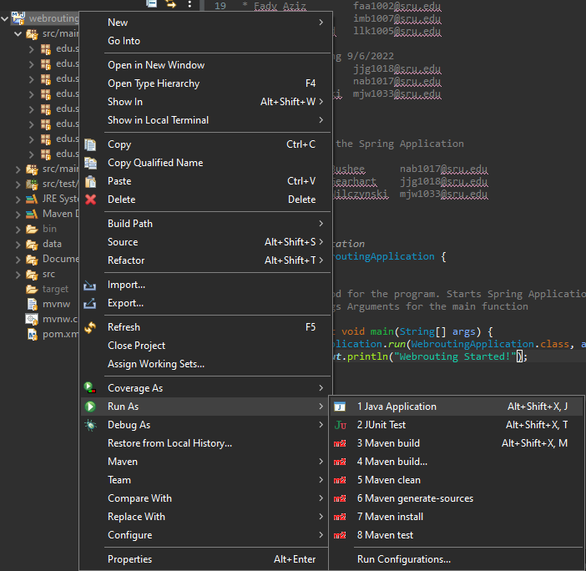

Figure 14 – Run Webrouting Application

After selecting this the application will begin to run at the bottom of your ***Eclipse IDE*** the ***Console*** should appear. Watch this ***Console***, this may take a few minutes.

Wait until you See “***Webrouting Started!”*** at the bottom of the console (See Figure 15).

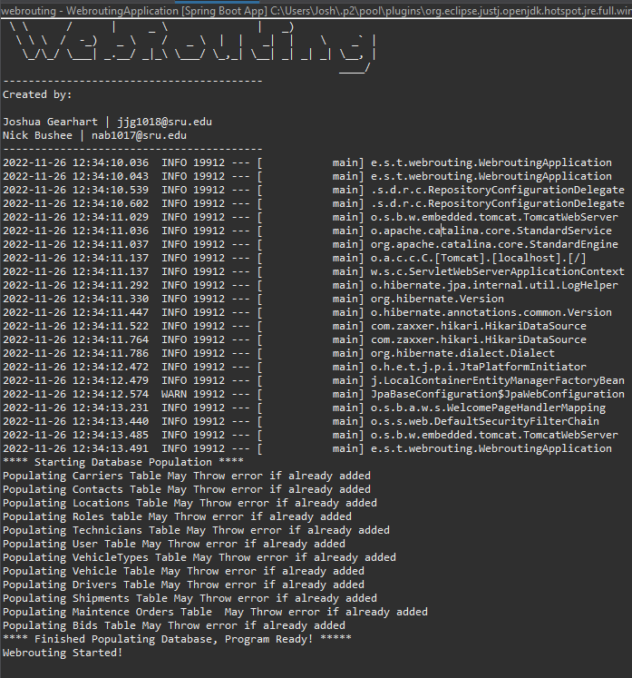

Figure 15 – Webrouting Console

Once verifying that the ***Webrouting Started!*** Message has been displayed you may now move on to accessing the Application (See section 6).

# 6. Accessing the Application

This section will show you how to access the Webrouting Application once it’s started.

## 6.1 Where to Access the Application

To open the application an internet browser is required. Open any internet browser of your choice once the application is running type <http://localhost:8080/> into the search bar. This will you take you to the ***Enterprise Routing System*** home page (Figure 16).

Figure 16 - Enterprise Routing Home Page

For more information and detailed guide on using the program please refer to the ***User Manual.***

# 7. Figures

Figure 1 - Download ZIP Button 3

Figure 2 – Launch Eclipse with File as Workspace 4

Figure 3 – Webrouting Application 4

Figure 4 – Updating Maven Project 5

Figure 5 –Import Button 6

Figure 6 – Import Menu 7

Figure 7 – Clone URI 8

Figure 8 – Source Git Repository Window 9

Figure 9 – Branch Selection Window 9

Figure 10 – MySQL Local Instance/Connection 10

Figure 11 – Server Status Button 11

Figure 12 – Administration – Server Status 11

Figure 13 – Application Properties file 12

Figure 14 – Run Webrouting Application 13

Figure 15 – Webrouting Console 14

Figure 16 - Enterprise Routing Home Page 15